Linux Servers
Joni Korpihalkola
Classroom Assignment 1 – Initial labwork
Document your commands or take screenshots. Answer questions in english or finnish.
- Set default VM locations
Create a folder to D: with your student-Id and set VirtualBox to use this folder for the default VM location (File – Preferences – Default Machine folder). IT IS ESSENTIAL TO SET THIS OPTION FIRST. Otherwise the VMs will be stored in your profile and you will be unable to log out cleanly.
- Template VM
Fetch the CentOS7 virtual machine template from network path (\\ghost.labranet.jamk.fi\TEMP\TempJojuh\LinuxServers) and copy it to your workstations D:
Do not double click and open the template from the network path! Copy it to your machine first.
Import the machine to your VirtualBox (File – Import). Name the VM as CentOS7 Template. This machine will be used for cloning additional VMs for the duration of the course.
- Cloning
Clone three new VMs from your template. Always check the “Re-Initialize MAC Address” checkbox, otherwise the machines will have same MAC addresses.
Name the machines Router, Admin and ClientB (Note: there will be no ClientA)
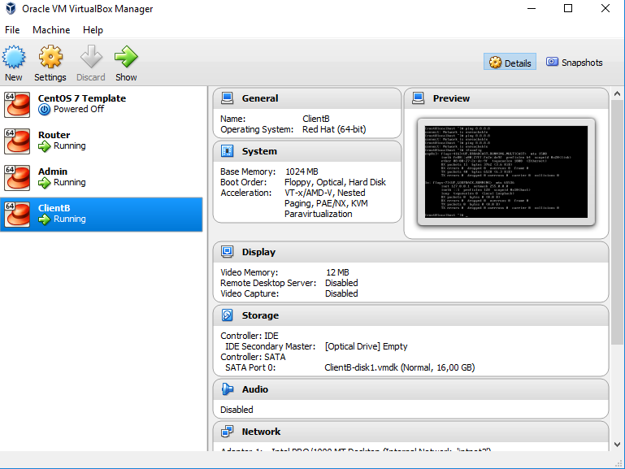
Template on kloonattu kolme kertaa ja eri virtuaalikoneet nimetty.

- Initial network config
Check that the Router VM has one network card connected to a bridged adapter. (Settings – Network – Adapter1 – Attached to: Bridged). Start the VM and log on, default credentials are root / root66
Check the default interface name with ifconfig. Also check that it has an IP address. If not, check the settings with nmtui. IPv4 address should be set to Auto and the ”Automatically Connect” checkbox should be set. Check your VM bridging options and try systemctl restart network.
Also check that SSH daemon is on with systemctl status sshd. It should show as active and loaded. You can now connect to the VM with PuTTY for easier use.
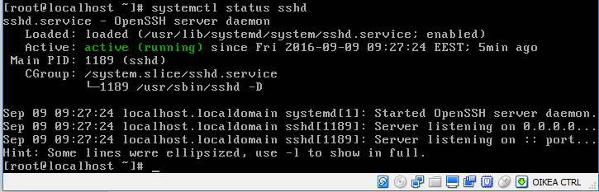
Sshd palvelu on ladattu ja päällä.
- Adding networks
Stop the VM with poweroff. Enable two more network adapters to the VM via Settings – Network. Set both new adapters as Internal network, Adapter 2 to intnet and Adapter 3 to intnet2. Start the VM again and check the new adapters with ifconfig -a. Compare the MAC addresses to the VirtualBox information and determine in which order the adapters are.
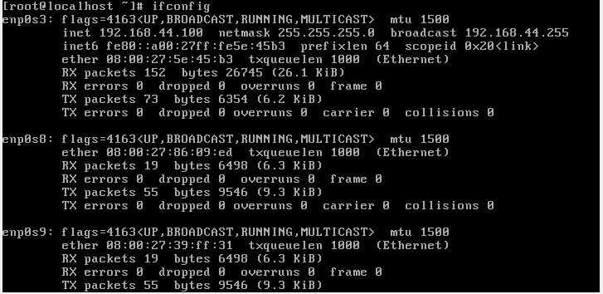
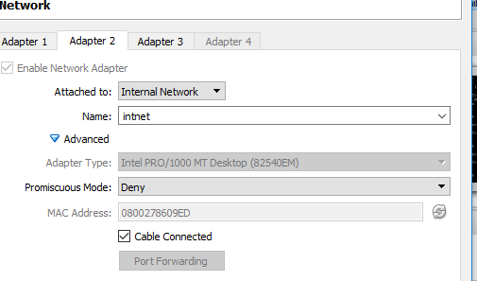
Enp0s8 on intnet.
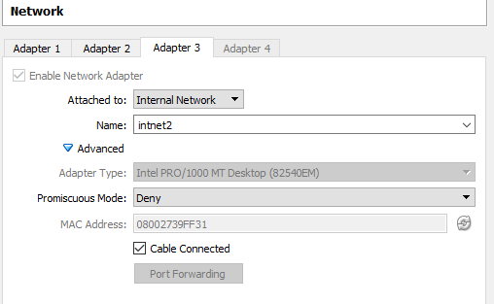
Enp0s9 on intnet2

For the other VMs, set the Admin VM network adapter to intnet and ClientB to intnet2. The network configuration will be done later during the course but your classroom topology is now following:

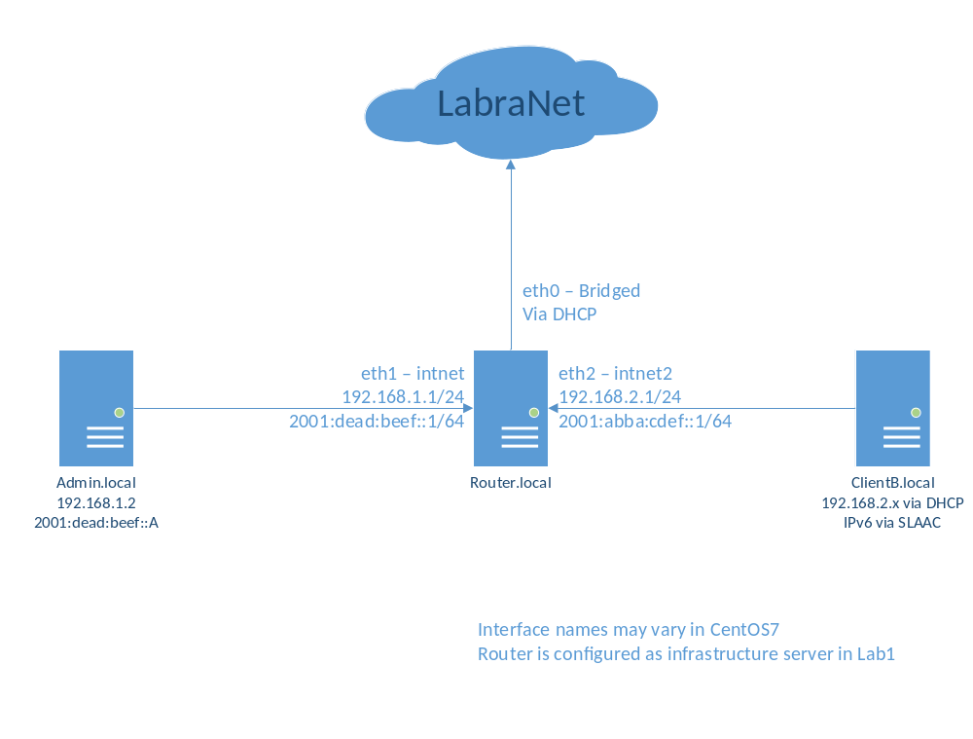
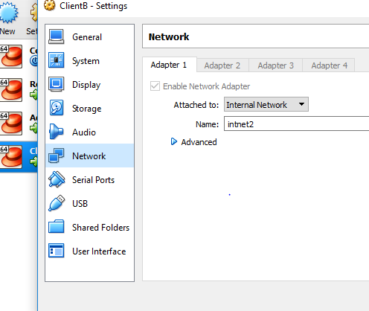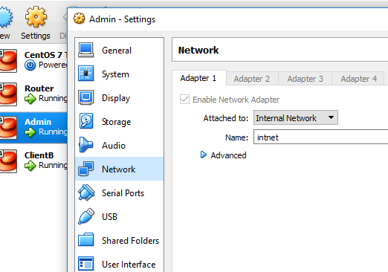
ClientB ja Admin – koneitten verkkorajapinnoiksi on nyt laitettu intnet ja intnet 2.

